In Adagio Purchase Orders click on PO/Receipt in the upper left-hand corner.

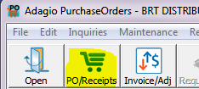

Select New 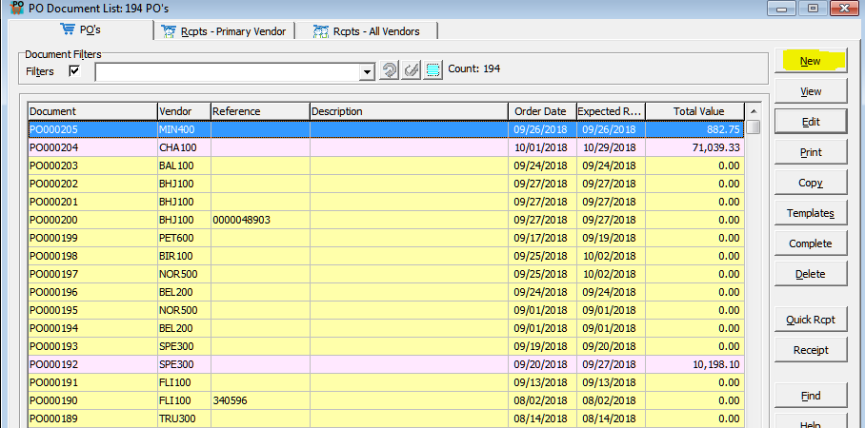

In the Header Tab ender the Vendor ID

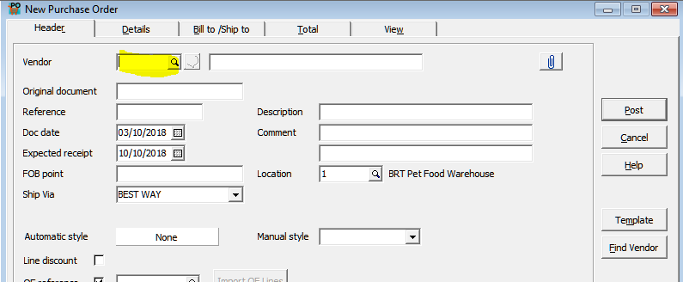

Then in the Details tab enter the items you are ordering.

* 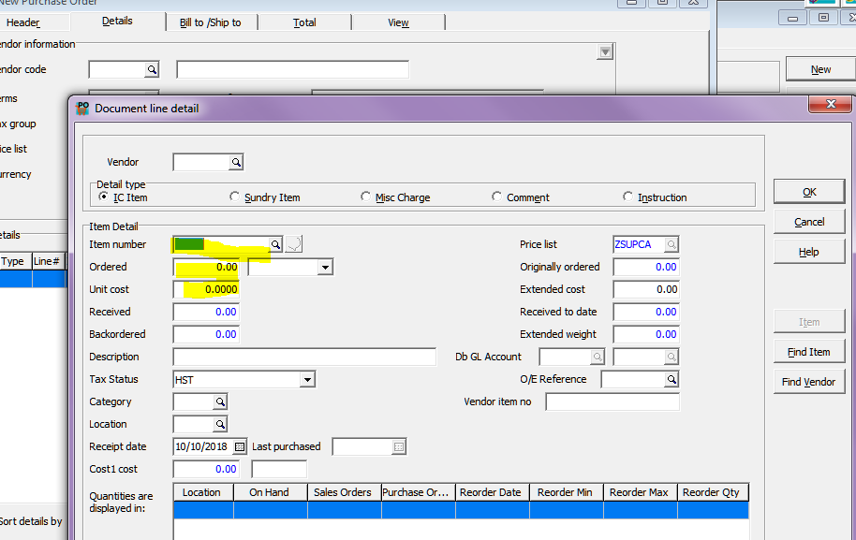Put the amount you are ordering in the Ordered field.
* Make sure the cost is correct.

When Entering a Freight Cost you change the detail type to misc. charge

The Vendor is the freight Vendor, even if it’s not the same vendor for the other items.

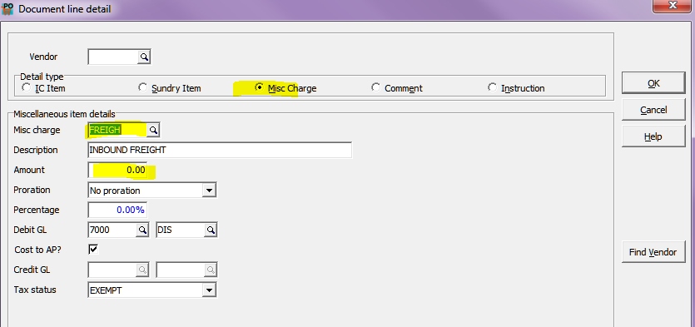

Once all items are entered Post your PO and print